
LESSON NOTE | DETAILED EXPLANATORY NOTES
GENETICS & MOLECULAR BIOLOGY
CHROMOSOMAL MUTATIONS
GRADE 12 - BIOLOGY

■ ■ ■

When Chromosomes Change
Genes are carried on chromosomes, and normally each body cell has the correct number and arrangement of them (humans have 46, in 23 pairs). A chromosomal mutation is a change to the structure or number of chromosomes - a larger-scale change than a gene mutation, which alters just one or a few DNA bases. Because a single chromosome carries hundreds or thousands of genes, chromosomal mutations can have major effects on the organism.
This lesson describes the two main groups: structural mutations (deletion, duplication, inversion, translocation) and numerical mutations caused by non-disjunction, which lead to conditions such as Down syndrome. It explains how these arise, their effects, and why they matter - an important part of the Genetics & Molecular Biology strand.
Why This Matters
- Chromosomal mutations can cause genetic disorders.
- They explain conditions such as Down syndrome.
- They are a source of genetic variation and can drive evolution.
- Understanding them supports genetic counselling and health care.
Chromosomal Mutations
Key Learning Outcomes
By the end of this lesson, students should be able to:
- Distinguish a chromosomal mutation from a gene mutation.
- Describe the four structural mutations and give an example of each.
- Explain non-disjunction and how it changes chromosome number.
- Give examples of disorders caused by chromosomal mutations.
- Explain causes of mutations and why they matter.
Structural Chromosome Mutations
Structural mutations change the arrangement of genes within one or more chromosomes. There are four main types. In a deletion, a segment of the chromosome is lost, so its genes are missing. In a duplication, a segment is repeated, giving extra copies of some genes. In an inversion, a segment breaks off, flips around, and rejoins in reverse order. In a translocation, a piece of one chromosome swaps to or joins a different (non-homologous) chromosome. Each type disturbs the normal set of genes, and the effect depends on which genes are involved.
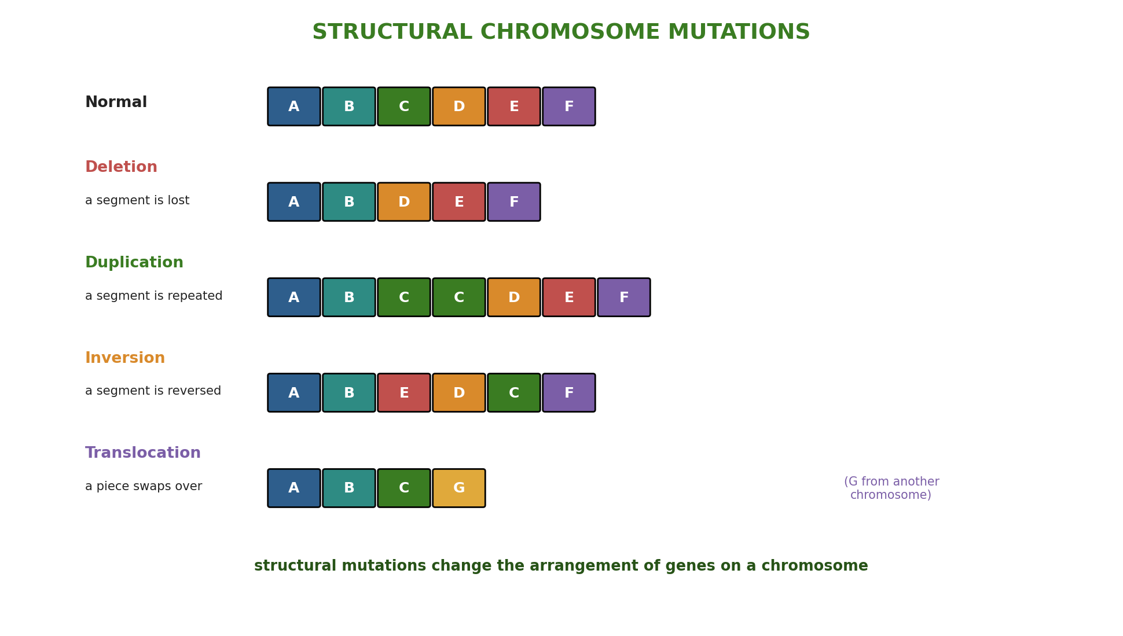
Figure 1: The four structural chromosome mutations - deletion, duplication, inversion and translocation.
Terminologies and Concepts
Useful terms for this topic:
- Chromosomal mutation: a change in the structure or number of chromosomes.
- Deletion / duplication: a segment is lost / repeated.
- Inversion / translocation: a segment is reversed / moved to another chromosome.
- Non-disjunction: failure of chromosomes to separate during cell division.
- Aneuploidy: having an abnormal number of chromosomes (e.g. one extra).
- Trisomy: having three copies of a chromosome instead of two (2n + 1).
- Karyotype: a picture of all an individual's chromosomes, used to spot changes.
Numerical Mutations - Non-Disjunction
Sometimes the number of chromosomes changes. This usually happens during meiosis (the cell division that makes gametes) through non-disjunction - when a pair of chromosomes fails to separate properly. The result is gametes with the wrong number of chromosomes: one gamete gets an extra chromosome, and the other is missing one. If such a gamete takes part in fertilization, the offspring has an abnormal chromosome number - for example a trisomy (2n + 1), with three copies of one chromosome instead of two.
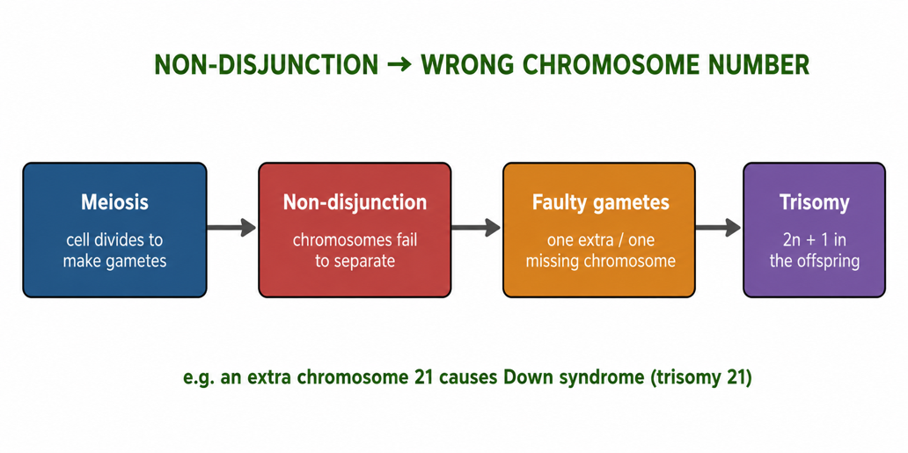
Figure 2: Non-disjunction during meiosis produces gametes with too many or too few chromosomes.
Effects of Chromosomal Mutations
Because chromosomes carry so many genes, these mutations often have serious effects. Down syndrome is caused by an extra chromosome 21 (trisomy 21), leading to characteristic features and intellectual differences. Turner syndrome results from a female having only one X chromosome (XO), and Klinefelter syndrome from a male having an extra X (XXY). Cri-du-chat syndrome is caused by a deletion on chromosome 5. Many chromosomal changes are so severe that the embryo does not survive, which is why they are a common cause of miscarriage.
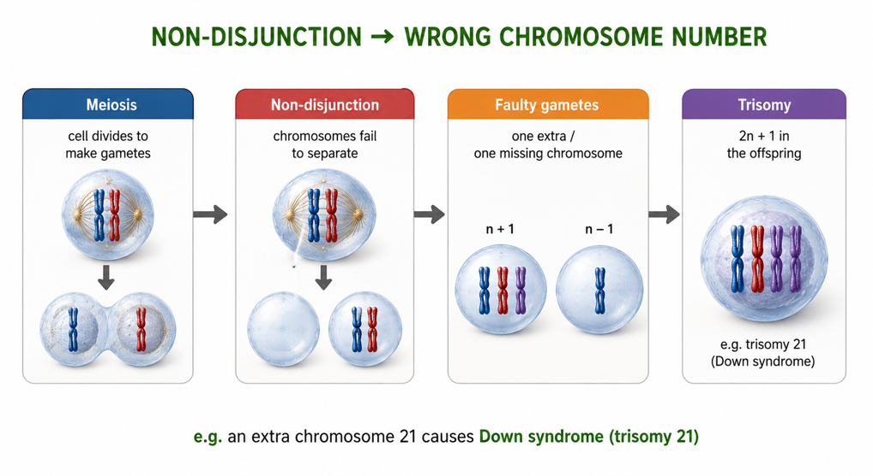
Figure 3: Some conditions caused by chromosomal mutations.
What Causes Mutations?
Mutations can happen spontaneously during DNA copying or cell division - errors that occur naturally at a low rate. Their frequency is increased by mutagens: radiation (such as X-rays and UV light), certain chemicals (like those in tobacco smoke), and some viruses. For non-disjunction, the risk rises with the mother's age. Most mutations are harmful or neutral, but a rare few are beneficial - and it is these rare beneficial mutations, passed on and selected over time, that provide the variation on which evolution acts.
Why This Matters
- Health - chromosomal mutations cause many genetic disorders.
- Diagnosis - a karyotype can detect them before or after birth.
- Counselling - understanding them helps families understand risks.
- Evolution - mutations are the ultimate source of genetic variation.
PNG Context Example
Awareness of chromosomal mutations supports health care in Papua New Guinea. Down syndrome and other chromosomal conditions occur in all populations, and understanding their cause helps reduce stigma and improve care and support for affected children and families. Knowing that some mutagens - such as tobacco smoke, betel-nut related chemicals, and radiation - can increase mutation rates encourages healthier choices. Basic genetic awareness also prepares students and future health workers to explain these conditions accurately and compassionately in their communities.
References & Related Documents
Source Documents
- Biology Standards-Based Syllabus, Grades 11 & 12 (PNG SBC 2020) - Strand: Genetics & Molecular Biology; investigate mutations and their effects, including chromosomal mutations.
- STEM Biology Syllabus - Grade 12. Thema: Genetics; Module: Mutations and Variation. Department of Education, PNG.
Further Reading & References
- OpenStax Biology - Chromosomal Basis of Inheritance; Chromosomal Mutations; Non-disjunction. https://openstax.org/books/biology
- Khan Academy - Chromosomal mutations and genetic disorders. https://www.khanacademy.org/science/biology

